**ARYAMAN MISHRA**

**19BCE1027**

Create an interactive dashboard for the Covid 19 dataset with at least 4 sheets by applying Filter action. Explain the step by step process and insights.

Sheet 1: create two bar charts for confirmed cases of the year 2020 and 2021.

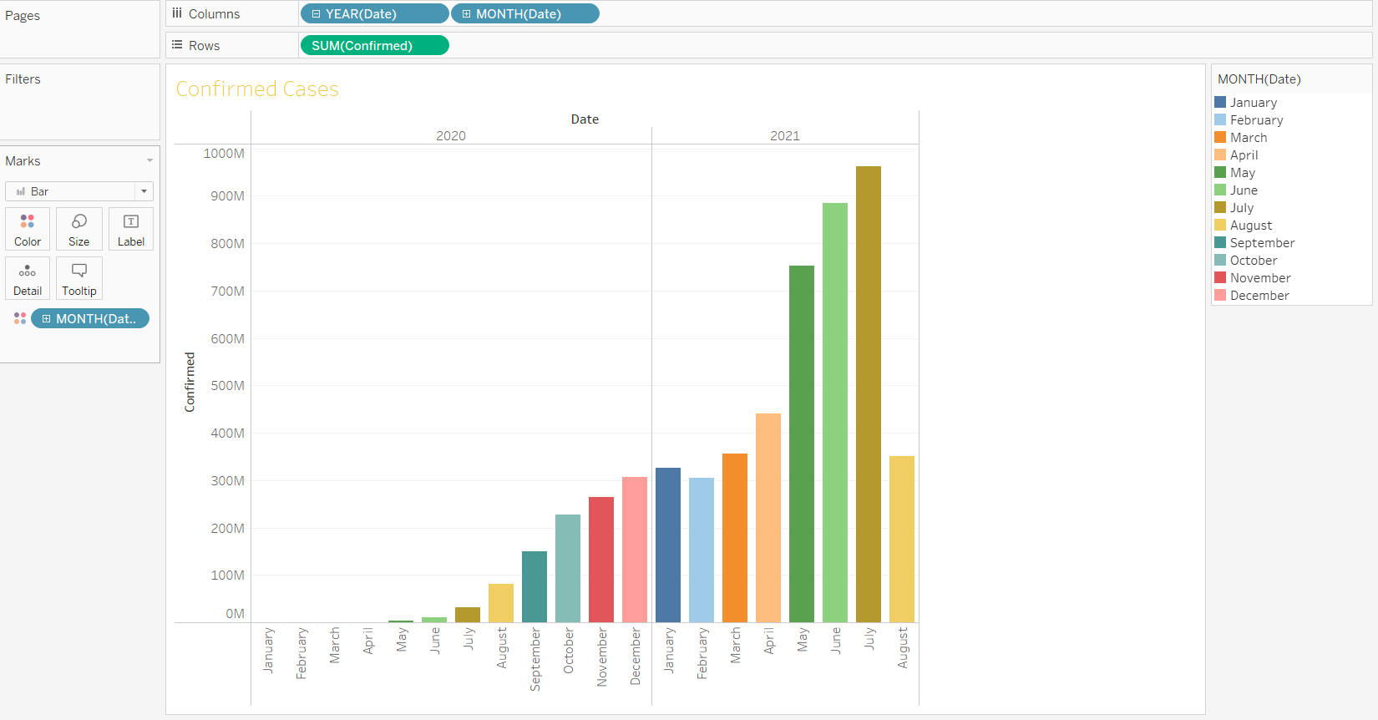

Sheet 2: create two line charts for cured cases for the year 2020 and 2021.

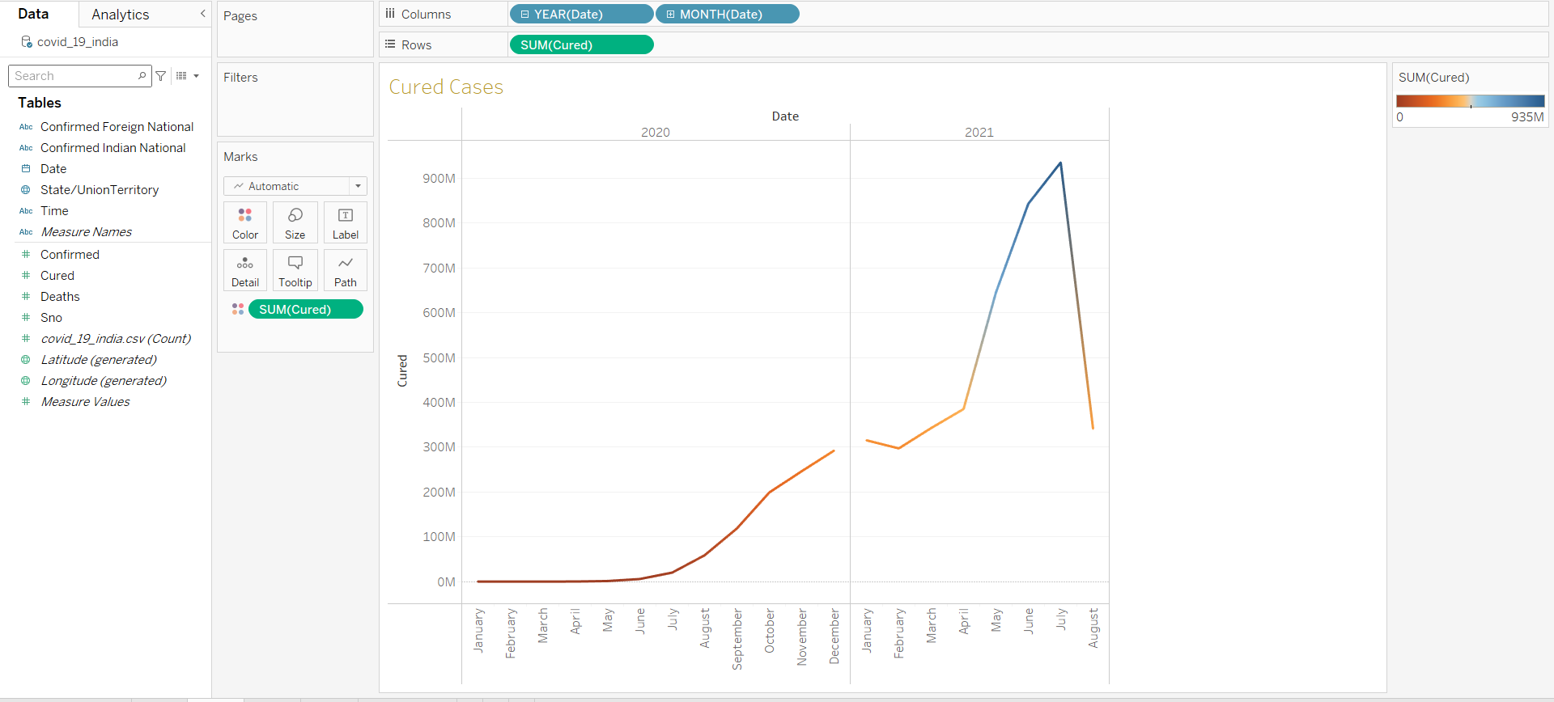

Sheet 3: create two area charts for deaths cases for the year 2020 and 2021.

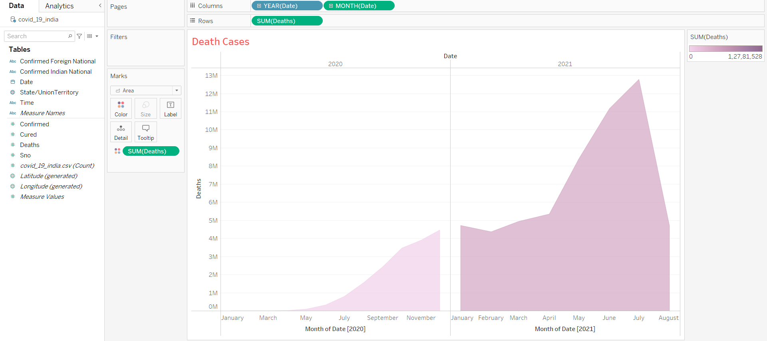

Sheet 4: create symbol maps to show state/union territory and apply filter action. When a state/union territory is selected then the Confirmed/Cured/Deaths values must be changed as per the selection.

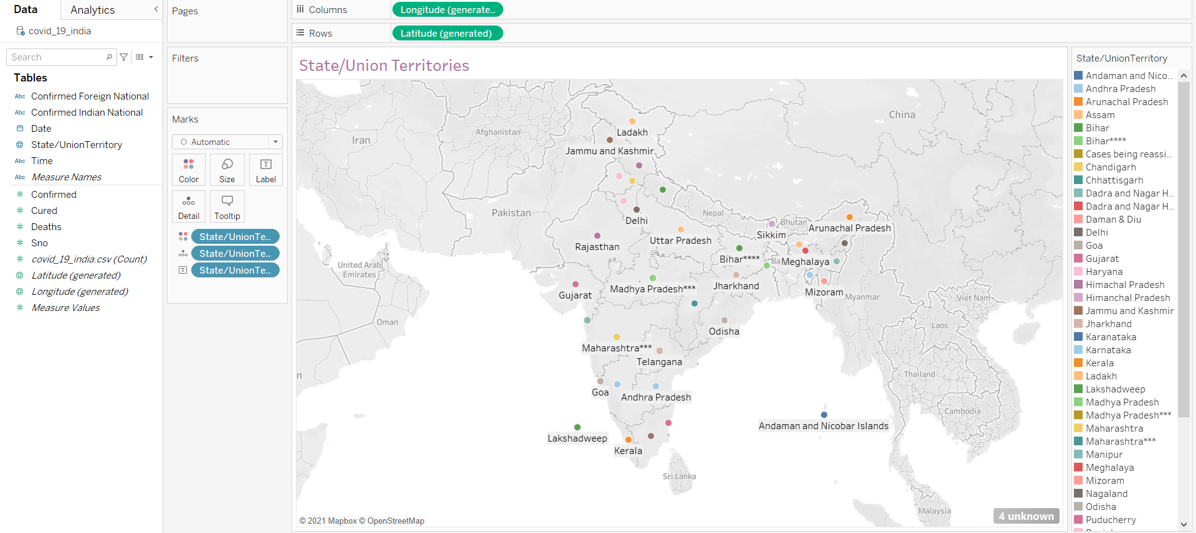

Create a Dashboard to merge all the plots. 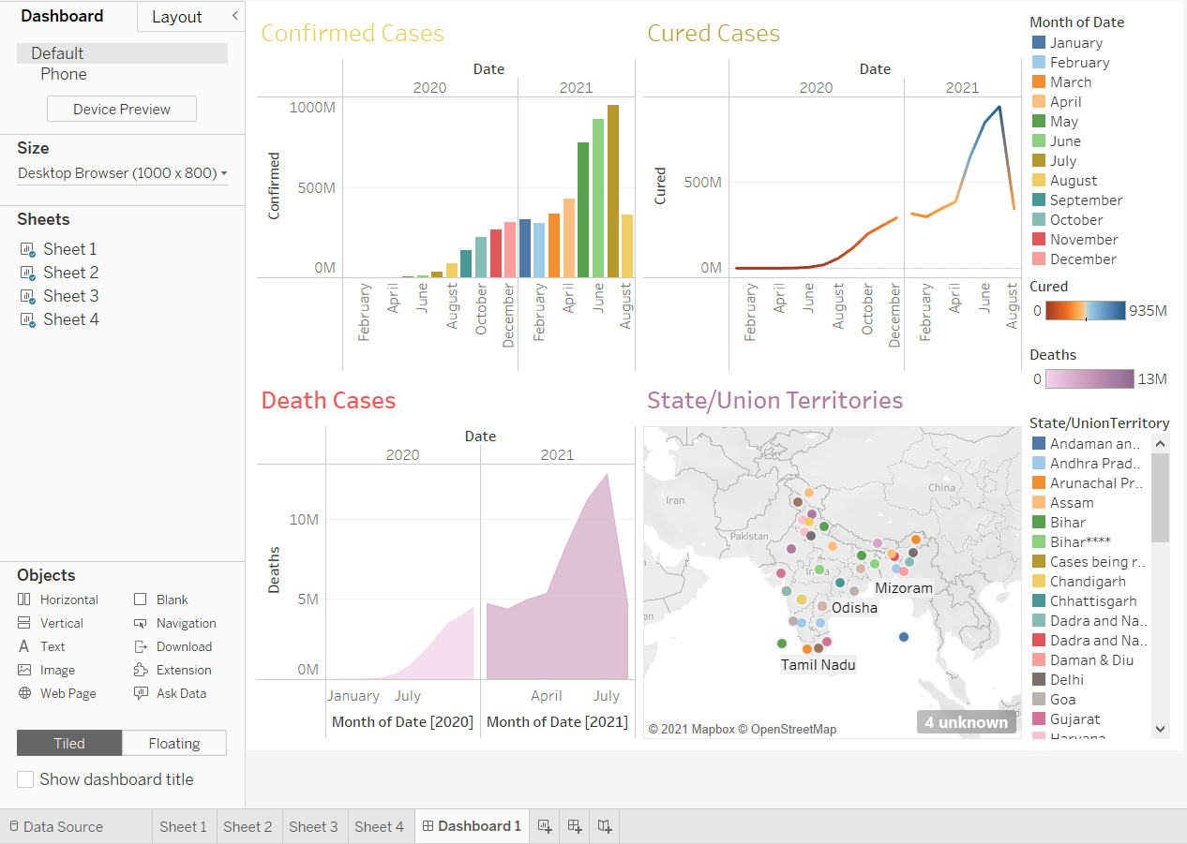

Access the Analytics menu for forecasting option and drag Forecast option to all sheets.

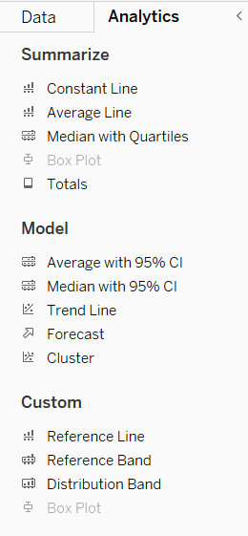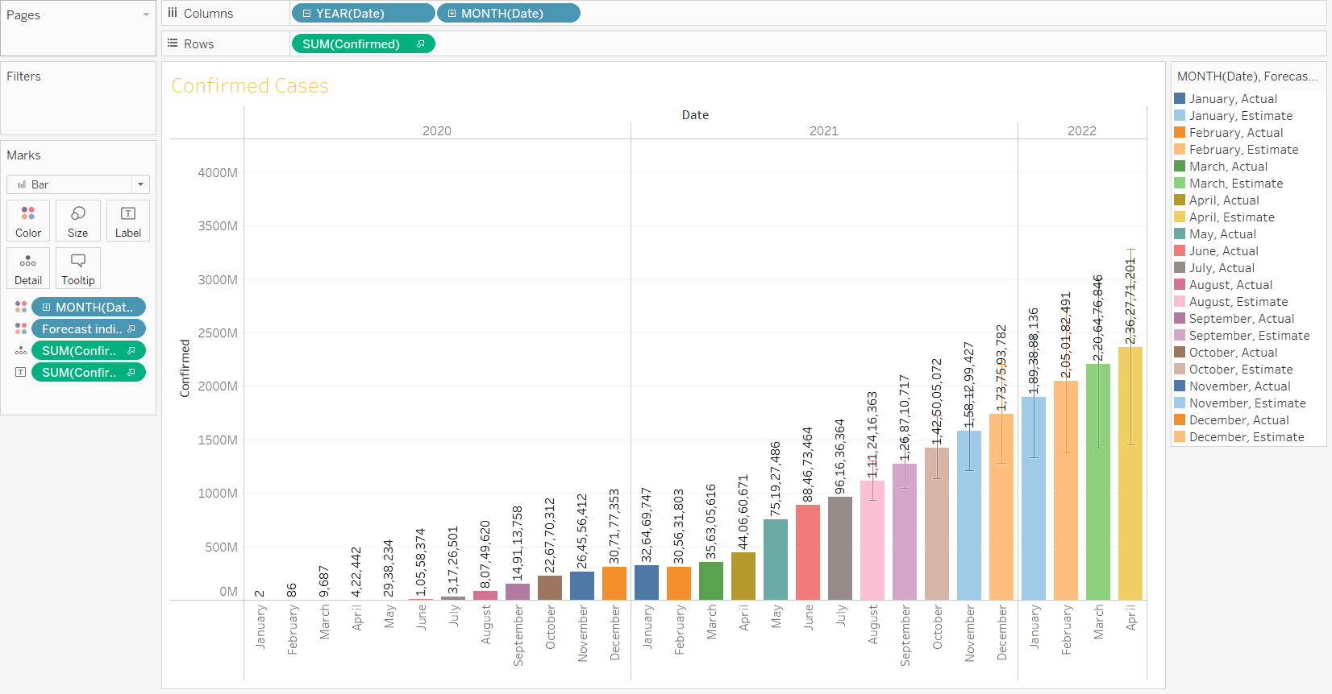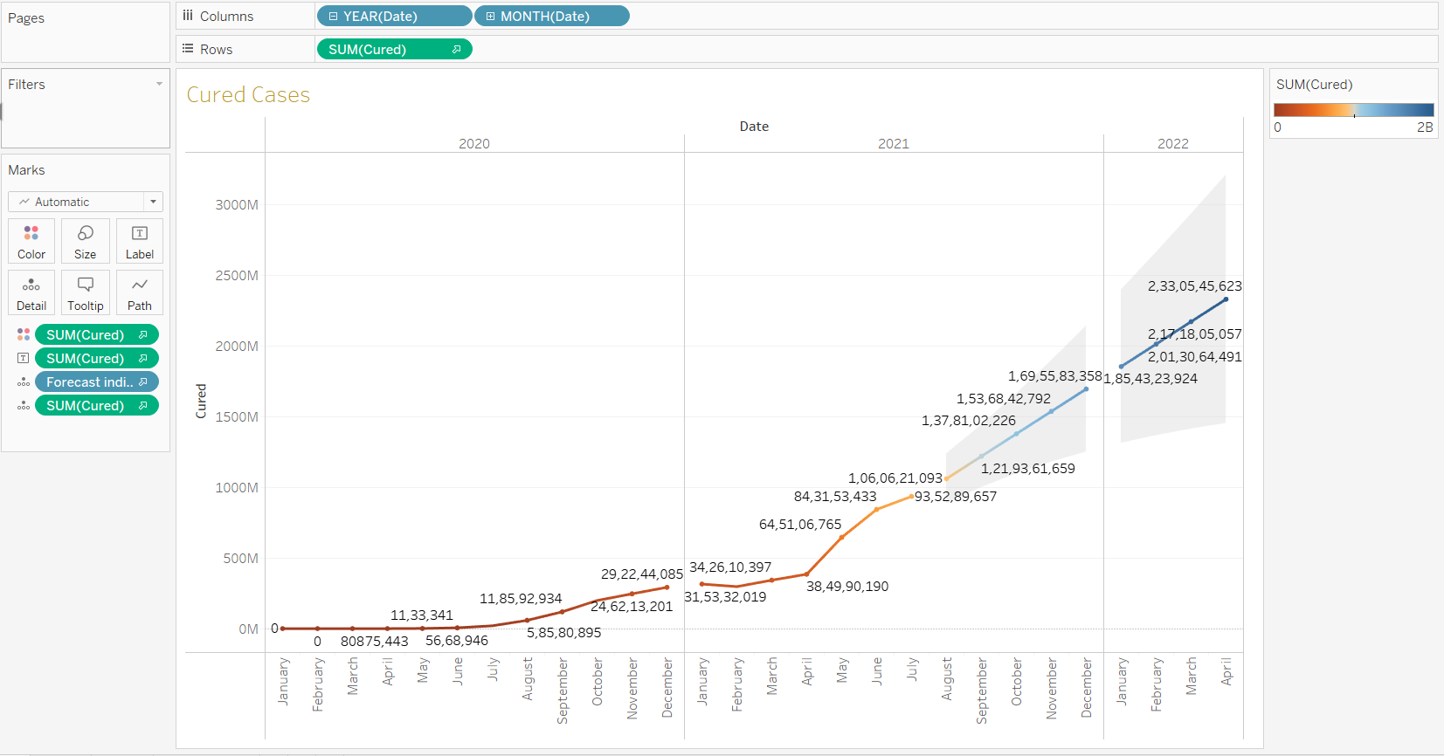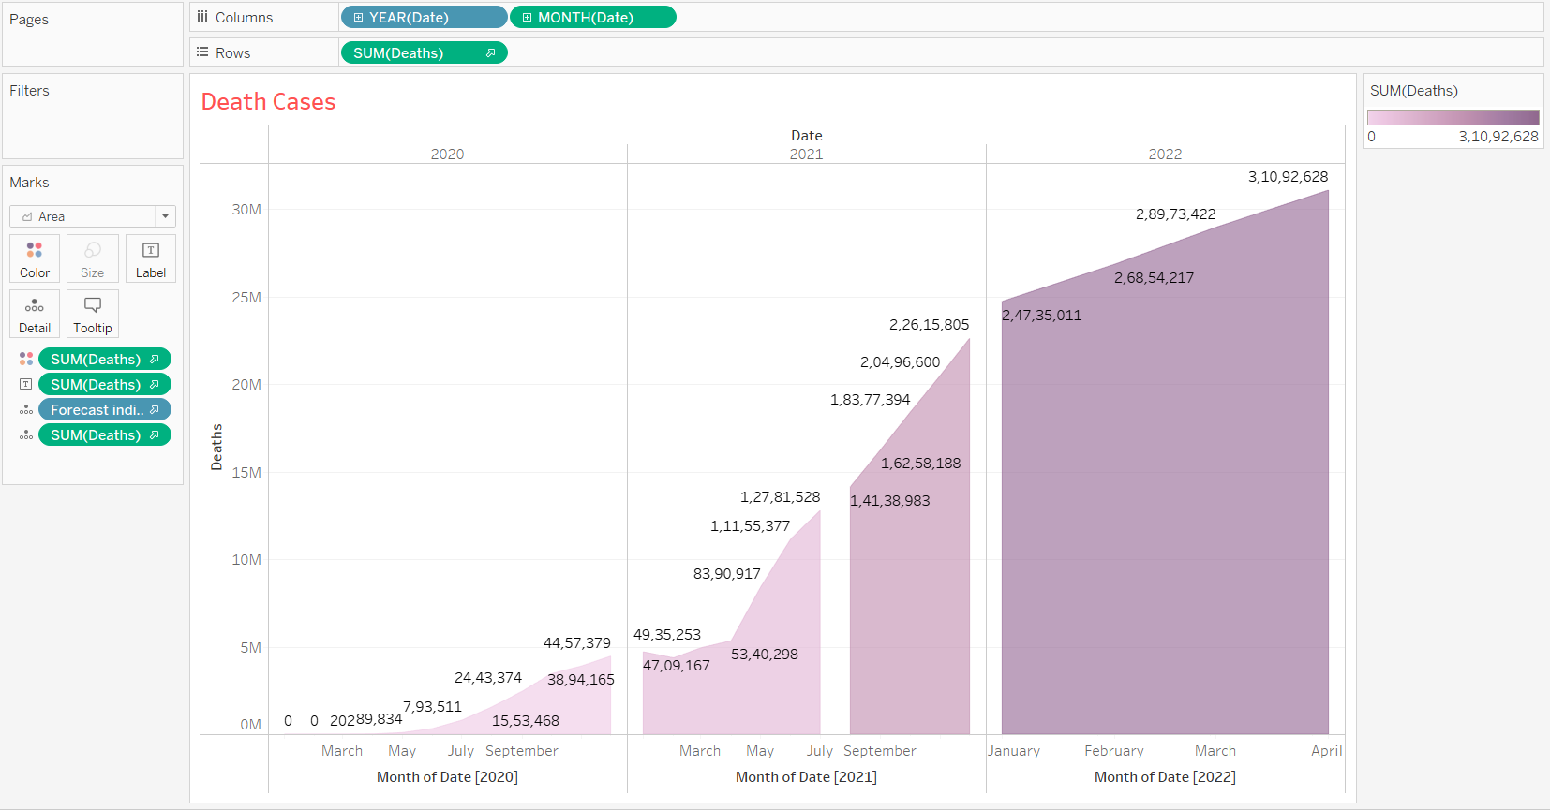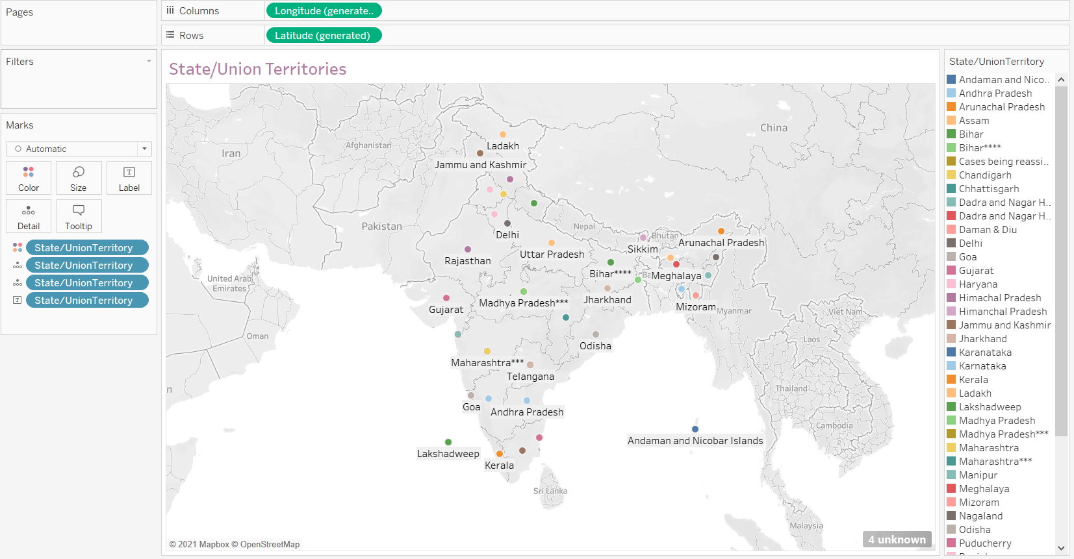

The first 3 sheets will now predict the data for the year 2022.This will also be reflected in the final dashboard.

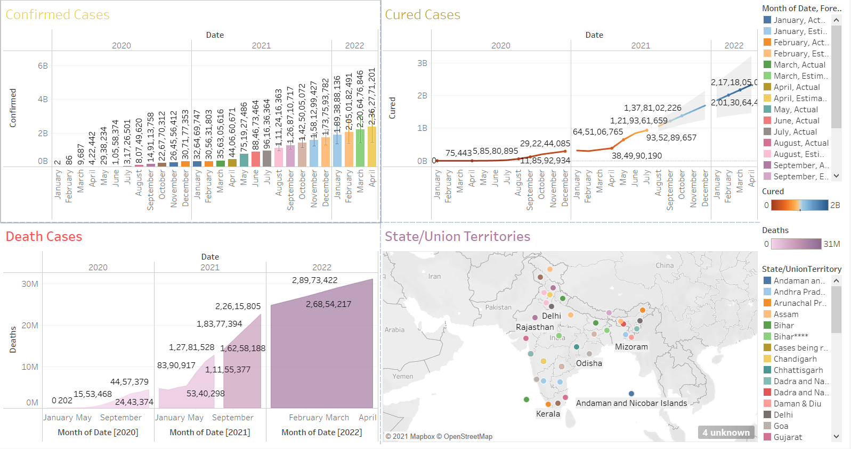

Add the filter option to apply only on States/Union Territories such that change will be reflected in the other sheets when a state is selected.The data will change corresponding to the state in the other 3 plots.Keep States/UT chart as source and else as target sheets.

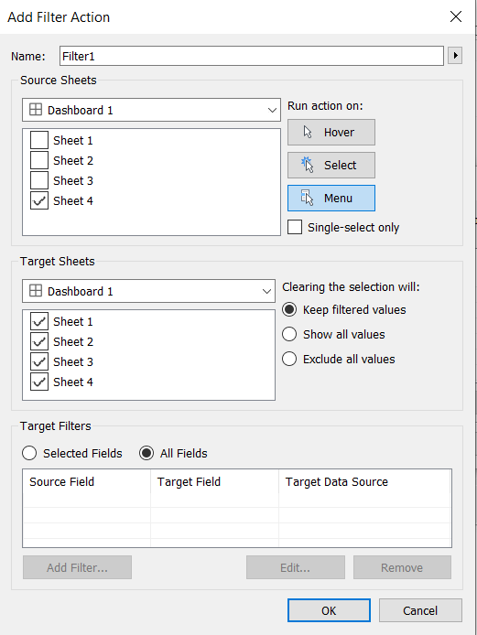

Our dashboard is ready for use: 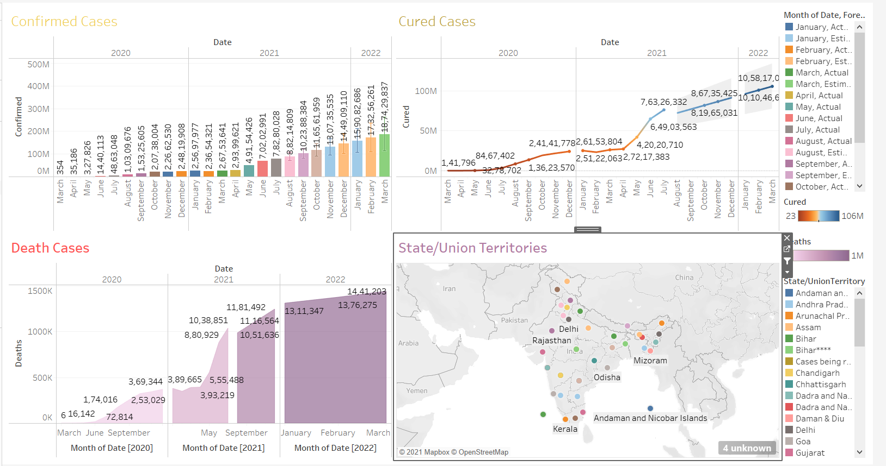

We can view Uttar Pradesh’s and Tamil Nadu’s data and compare it.

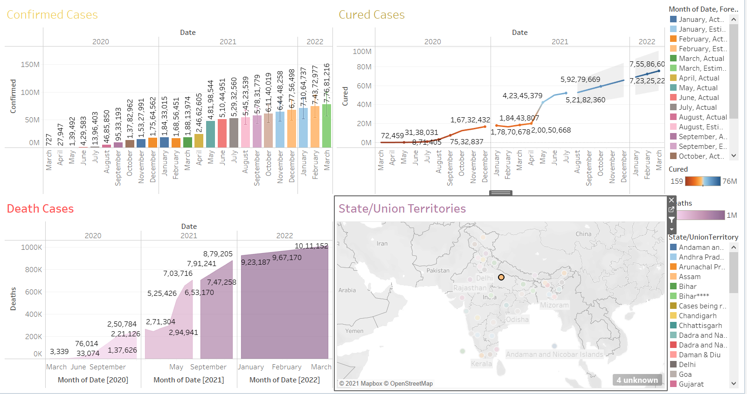

. 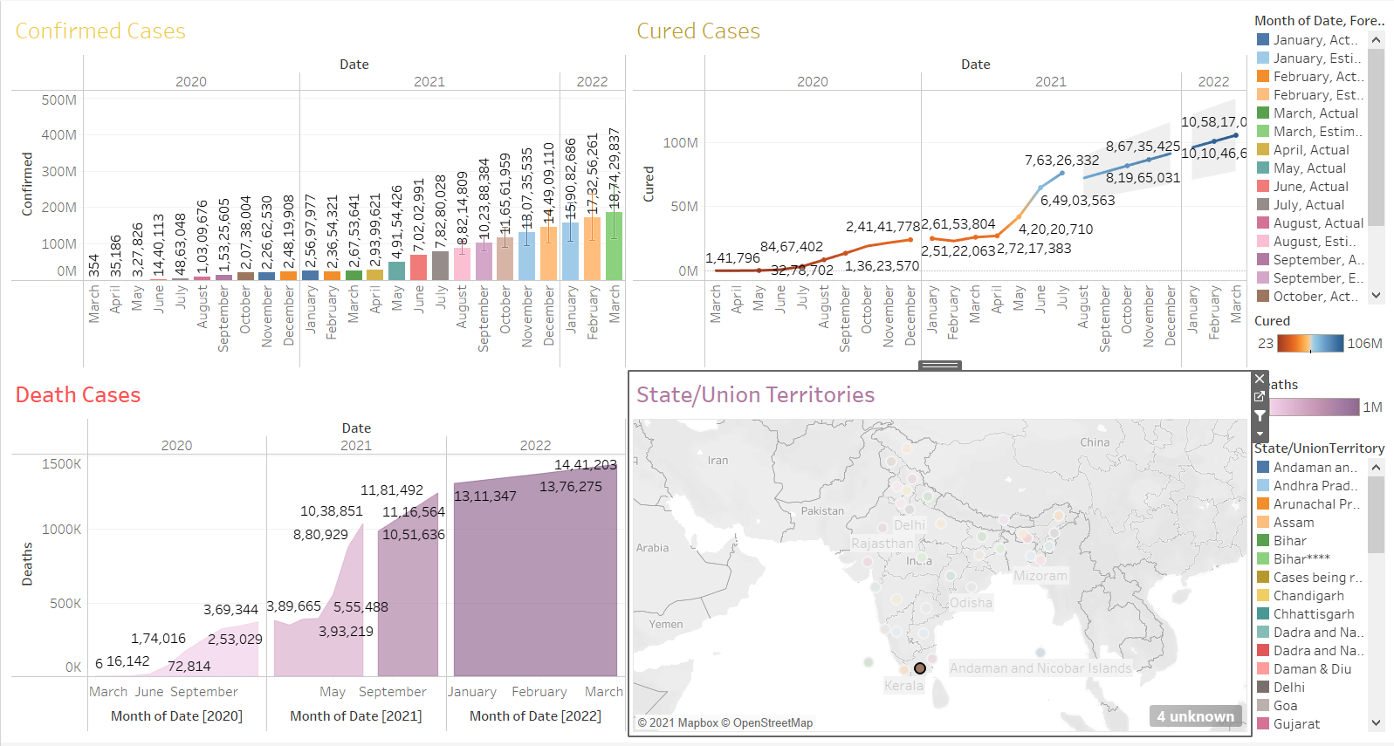

Out of all the states,Delhi has the highest amount of cases and forecasted numbers. 